

NSL (NATIONAL STOCK LISTING) RETIREMENT REQUIREMENTS

THIS DOCUMENT PROVICES A CLEAR & EXPLICIT, IMPLEMENTATION OF CATALOGUE ITEM MODEL. THIS BUSINESS REQUIREMENT DOCUMENT OUTLINES THE BUSINESS OBJECTIVES, FUNCTIONAL REQUIREMENTS, OPERATIONAL PROCESSES AND SUCCCESS METRICS FOR DEPLOYING THE NEW PRODUCT IDENTIFIER SUPPORTING END-TO-END PROCESSES.

VERSION CONTROL

Date | Details of Update | Author
20.05.26 | INITIAL DRAFT CREATED | HATICE HIZLI
21.05.26 | Updated Purpose & Background, Business Objectives, In Scope and Out of Scope, Stakeholders KDDs, | HATICE HIZLI
22.05.26 | Updated Assumptions, Dependencies, Risks & Mitigations, Master Data Products reviewing RTM to gather requirements (WIP) | HATICE HIZLI
26.05.26 | Updated master data product data requirements from RTM document (WIP), updated scope and out of scope from LLD document | HATICE HIZLI
27.05.26 | Updated master data product data requirements from RTM document (Completed), populated Promo, Prices, Sales Order, Order Acknowledgement requirements from RTM document (WIP) | HATICE HIZLI
28.05.26 | Updated Promo, Prices, Sales Order, Order Acknowledgement, Schedules, EDN requirements from RTM document (Complete) Added Data Model and to-be integration images from HDL document | HATICE HIZLI
29.05.26 | Updated Integration Details (Appendix1), API capabilities and behaviour, Business Clocks, Success Criteria | HATICE HIZLI
01.06.26 | Updated Product hierarchy, Suppliers, Invoices, CR/DR Notes, Promotional Sales, Claims, Promotion settlements, added table for glossary of terms | HATICE HIZLI
02.06.26 | Updated Glossary of Terms | HATICE HIZLI
03.06.26 | Added more requirements to Invoices, Schedules and Sales Orders as the latest version of RTM (v1.3) had more requirements than RTM v0.14 | HATICE HIZLI
09.06.26 | Updated more requirements as per RTM (Must Have Moscow Statuses) after meeting with business stakeholders identifying Lincolnshire Co-op related requirements to be added to the document | HATICE HIZLI
29.06.26 | Strike through requirements that has been confirmed by business that are not required after first round of reviews | HATICE HIZLI
30.06.26 | The requirements updated after the meeting with Jamie Lawson, Lee Trayford and Claire O’Hare additional RTM requirements added, after the group agreed to capture “Should Have” and “Could Have” requirements in the BRD. | HATICE HIZLI
01.07.26 | As Above Ditto | HATICE HIZLI
02.07.26 | As Above Ditto | HATICE HIZLI
03.07.26 | As Above Ditto Added Documentation & Communication (9.2) | HATICE HIZLI
22.07.26 | Added/removed requirements from document after SME reviews and meeting held with Claire O’Hare | HATICE HIZLI
24.07.26 | Reconciling against RTM to make sure all required captured and documented | HATICE HIZLI
27.07.26 | As Above Ditto | HATICE HIZLI
28.07.26 | As Above Ditto | HATICE HIZLI

APPROVALS

DATE | NAME | ROLE | SIGNATURE

CONTENTS

1. Purpose & Background 5
2. Business Objectives 5
3. Scope 6
3.1 In Scope – High Level 6
3.1.1 In Scope – Low Level 7
3.2 Out of Scope – High Level 7
3.2.1 Out of Scope – Low Level 7
3. Stakeholders 8
4. Key Design Decisions 8
6. Core Retail Systems 9
7. Data Model 10
8. Functional Requirements 10
8.1 Master Data 10
8.1.1 Products 11
8.1.2 Prices 14
8.1.3 Promotions 15
8.1.4 Suppliers 16
8.1.5 Product Hierarchy 16
8.2 Transactional Data 17
8.2.1 Sales Order 17
8.2.2 Order Acknowledgements 18
8.2.3 Electronic Delivery Notifications (EDNs) 19
8.2.4 Invoices 19
8.2.5 Claims 20
8.2.5.1 Credit/Debit Notes 20
8.2.6 Promotional Sales Volumes 20
8.2.6.1 Promotional Settlement 20
8.3 JDA (Blue Yonder) – Range and Space (Including Planograms and RADR Reports) 21
9. Support 23
9.1 Schedules 23
9.2 Documentation & Communication 26
10. API Capabilities & Behaviour 26
10.1 Delta Queries 26
10.2 Authentication & Authorisation 26
10.3 Pagination 26
10.4 Rate Limiting 26
10.5 Request Validation & Data Handling 26
10.6 API Versioning 26
10.7 API Contracts 27
10.8 Error Handling 27
11. Business Clocks 27
11.1 Business Clocks – AS-IS 27
11.1.1 Range Events 27
11.1.2 Promotional 28
11.1.3 Price Changes 29
11.1.4 Ordering Business Clock 29
11.1 Business Clocks – TO-BE 30
12. New Product Identifier Structure – TO-BE 30
13. Integration Requirements 31
14. Risks & Mitigations 33
15. Assumptions 34
16. Dependencies 34
17. Success Criteria 35
18. Implementation Approach 35
19. Timelines 35
20. Glossary of Terms 36
Appendix 1 38

Purpose & Background
As part of Retail Business Transformation Programme Co-op implemented SAP suite of products for its core retail systems and Blue Yonder (JDA) for ranging activity.
As part of implementation, most of the processes together with the management of master data were migrated from legacy systems to a centralised SAP system.
This data included Product, Price, Promotions, Supplier, Range and Space which was then distributed to all the channel and downstream systems.
The Retail Business Transformation Programme adopted the SAP Article as its new Product Identifier to support its processes.
The ‘Wholesale Order to Bill’ business processes that support the ISMs (Independent Society Member) who are part of FRTS (Franchise Retail Trading Services) Buying Group, are some of the remaining processes that continue to reside on the legacy systems, and which still rely on the old product identifier (NSL – National Stock Listing) and Retail Line.
The continuation of running these processes on legacy systems is creating significant issues (master data inconsistency/duplication, large number of file feeds (more than 300), data send/receive not in a timely manner, challenges in maintaining legacy systems slowing down future transformation opportunities)
The NSL Retirement Programme aims to remove the dependency on TCG’s
(The Co-operative Group) legacy systems. This includes the replacement of legacy product identifiers (NSL and Retail Line) with a ‘Catalogue Item’ model.

The NSL Product Identifier will be replaced with a Catalogue Item, which uniquely identifies a Wholesale Product and associated Sales Order unit. The Catalogue Item will be supported with all the corresponding data that is required by ISMs to order products from TCG. The Catalogue Item will be an alpha numeric code.

Business Objectives
- Opportunity to modernise and simplify the integrations that are required between TCG and the ISMs.
- Support shared strategic shift toward API (Application Programming Interface) first architecture enabling more reliable, secure, and efficient data exchange across master data and transactional data domains between TCG and ISMs.
- Support end -to -end processes by provisioning of a cleaner, more concise, and timely set of data.
- Introduce a new integration framework that leverages APIs and secure file feeds to deliver Product, Pricing, Promotion, Product Hirerarchy, Range, Sales Order and Billing Data, exported from TCGs strategic systems.
- Standardise product identification across all systems (ERP, POS, WMS, PIM)
- Eliminate duplicate or conflicting product identification.
- Improve data governance and reduce manual corrections.
- Reduce pricing and stock inaccuracies caused by inconsistent IDs.
- Enable future scalability for new categories, channels, and suppliers.
- Streamline data exchange.
- Reduce number of data feeds.
- Ensure seamless store operations.
- Single source of truth with shared master data between ISMs and TCG.

3. Scope

3.1 In Scope – High Level
# | In Scope | Details
1 | Modernised interfaces and  data integration | - Single source of truth for master data (Products, Prices, Hierarchies, Promotions, Suppliers and Range)  - Streamlined data exchange by using  pre-defined interface/API specifications  - A reduced number of master data feeds  - Removal of the need for manual data extraction, off systems reports, except for sharing information for pre-event notifications (e.g. GSM02 files for Range events, Promotional pack for Promotions)  - Consistent data across all interfaces (e.g. Product, Range etc.)  - Weekly full feed of master data for all the ISMs, which includes Product, Price, Hirerarchy, Promotion and Supplier data  - Near real-time updates of master data (the definition of near real-time will be agreed during detailed design  - Provide master data updates via APIs/file feeds for changes made within TCG core retail system that are relevant to ISMs (Products, Prices, Hierarchies, Promotions, Suppliers and Range data)  - Create a comprehensive data dictionary and document data flows for transparency and auditability
2 | Introduction of new orderable Product Identifier that will replace NSL code | - Provide the necessary master data to support the new orderable Product Identifier  - Update the transactional data flows to accept the  - Sales Orders, Order Acknowledgements and  - EDNs to refer to the new Orderable Product Identifier  - Review and update Billing and Invoicing related data flows to use the new orderable Product Identifier
3 | Remove the dependency on CTS (Corporate Trading System.  Co-op’s Legacy master data system) | • Source consistent master data from core retail systems
4 | Introduction of robust and secure integration platform utilising TCGs API first approach | • Support exchange of master data via APIs which includes Product, Price, Promotion, Supplier, Hierarchy data
5 | Master data attribute management | - Separation of key attributes from Descriptions, Product Size, Weight, and Standard Units (e.g. kilograms or pounds) to be stored in separate fields for compliance and clarity  - Inclusion of extended attributes, additional product attributes (e.g. allergen info, HFSS flags, regional restrictions)  - Consistent terminology across all master data feeds
6 | Transition requirements | - Persist current data structures and processes until new solutions are fully operational

3.1.1 In Scope – Low Level
- Retire NSL & Retail Line from the Buying Group and replace with a universal ID
- Retire price bands to be replaced with regional pricing
- New defined FRTS Buying Group Business Operating Model
- New Master Data API interfaces replacing daily Price/Promo bulletin & FRTS Portal
- New Transactional (ordering) intersections replacing Staging
- Simplified, standardised SAP reporting
- Build and test with ISMs to feedback for wider BSA learnings

3.2 Out of Scope – High Level
# | Out of Scope | Details
1 | Any Co-op involvement or influence with the system design or build on ISM systems. | • Legal restrictions under Competition Law
2 | NISA, Franchise, or any other Partners of NSL outside of the FRTS Buying Group | • Scope of the project includes only ISMs part of FRTS Buying group
3 | Introduction of Substitutions (e.g. different pack size of same article), if the products ordered by ISMs are not available for delivery, but an alternative is available? | • Substitutions will not be introduced as part of NSL Retirement project, due to impacts on Forecasting and Replenishment and complexities involved in financial reconciliation and Billing
4 | ISM Direct Ordering | • The principle will remain that ISMs will continue to order direct from certain suppliers
5 | Enhancements to Buying Services Agreement | • We will not deliver any consummate changes to the Buying Services Agreement (BSA) due to legal restrictions via Competition Law
6 | Logical data models detailed individual data attributes and API/Interface specifications | • Logical data models and API/Interface specifications will be provided as part of detailed design

3.2.1 Out of Scope – Low Level
- Changes to ISM ERP systems (ISM responsibility)
- Legacy TCG core documents e.g. GSM, ERC & seasonal allocations
- Development on CTS, Chain stores, or other legacy systems
- Like-for-like reporting & customised data functionality
- Individual UAT scenarios during delivery (ISM responsibility)

Stakeholders

Group | Name | Role/Department
Lincolnshire Co-op | Laura North | IS Solution Delivery Manager
Lincolnshire Co-op | Sam Eade | Project Manager – Food Support
Lincolnshire Co-op | Jamie Lawson | Process Support Manager
Lincolnshire Co-op | Lee Trayford | Process Support Manager
Lincolnshire Co-op | Susan Daniel | Finance Ledger Manager
Lincolnshire Co-op | Claire O’Hare | Micro Space Manager

Key Design Decisions

Ref | KDD Name | KDD Decision | Status
KDD 633 | How the master data will be made available to ISMs | Master data will be made available to ISMs via consolidated APIs and file feeds.  - APIs will provide near real time access for delta master data changes as the primary method.  - File feeds will support delta master data changes and weekly full feeds, where ISMs cannot consume APIs | Approved
KDD 634 | Support the Sales Order submission via APIs | Sales Orders will be accepted via API  - Sales Orders will be accepted via API, which will be validated in real time and provides confirmation of order receipt and error codes/reasons if it is rejected  - This is in addition to the file-based order submissions | Approved
KDD 635 | What will be the new identifier that replaces NSL | TCG will publish Catalogue Item s. These are single, customer-facing identifiers that uniquely identify a product and a Sales Ordering unit The Catalogue Item is the recommended identifier for placing orders, reconciling invoices, and handling customer enquiries  - A Catalogue Item uniquely identifies a Product and Sales Order unit and is represented by alpha-numeric code and will be included in the master data  - The Catalogue Item will be supported with the consumer Product EANs, Orderable Units, Orderable Unit EANs, NSL (where available during transition period) and product information  - A new Catalogue Item will be created if a new product or orderable unit (for an existing product) is introduced  - ISMs will use the Catalogue Item Code when placing the Sales Orders and any customer support/queries  - Consideration will be given to reserve a dedicated number range for ISMs to configure Catalogue Item codes for locally sourced products. | Approved
KDD642 | What will be the new format for outgoing data - Json or XML for all the Integrations | JSON format will be used for exchanging all the master data with the ISMs. For file-based interfaces JSONL format will be used. | Proposed

6. Core Retail Systems
Master data feeds from TCGs core retail systems which consists of:
- SAP ERP for Products, Prices, Promotions, Suppliers, Products, and hierarchies
- JDA (Blue Yonder) for Range and Space information which includes planograms, RADR reports.
TCG will setup master data and Range information in line with its existing business processes in SAP/JDA (Blue Yonder).
SAP and JDA (Blue Yonder) will be the system of record for all master data domains establishing a single source of truth.
SAP ERP will be changed, where required to:
- Include additional fields will be introduced on SAP to hold master data required by the ISMs which are not part of the standard field list, so that they can be shared with the ISMs.
- Identify all the changes to master data relevant to ISM and include it in the delta feeds.
- Provide weekly full master data feeds.

Blue Yonder (JDA) – Range and Space management component will be changed to:
- Include Product code, in addition to NSL on the planograms.
- Include Catalogue Item code in the RADR reports .
- Provide planograms and PSA files via automated interface, in addition to making them available via Open Access.
Master data relevant for ISMs will be exported from SAP and Blue Yonder (JDA) at periodic intervals. The frequency of the SAP exports will be XXXXXXXXXXXXX

7. Data Model

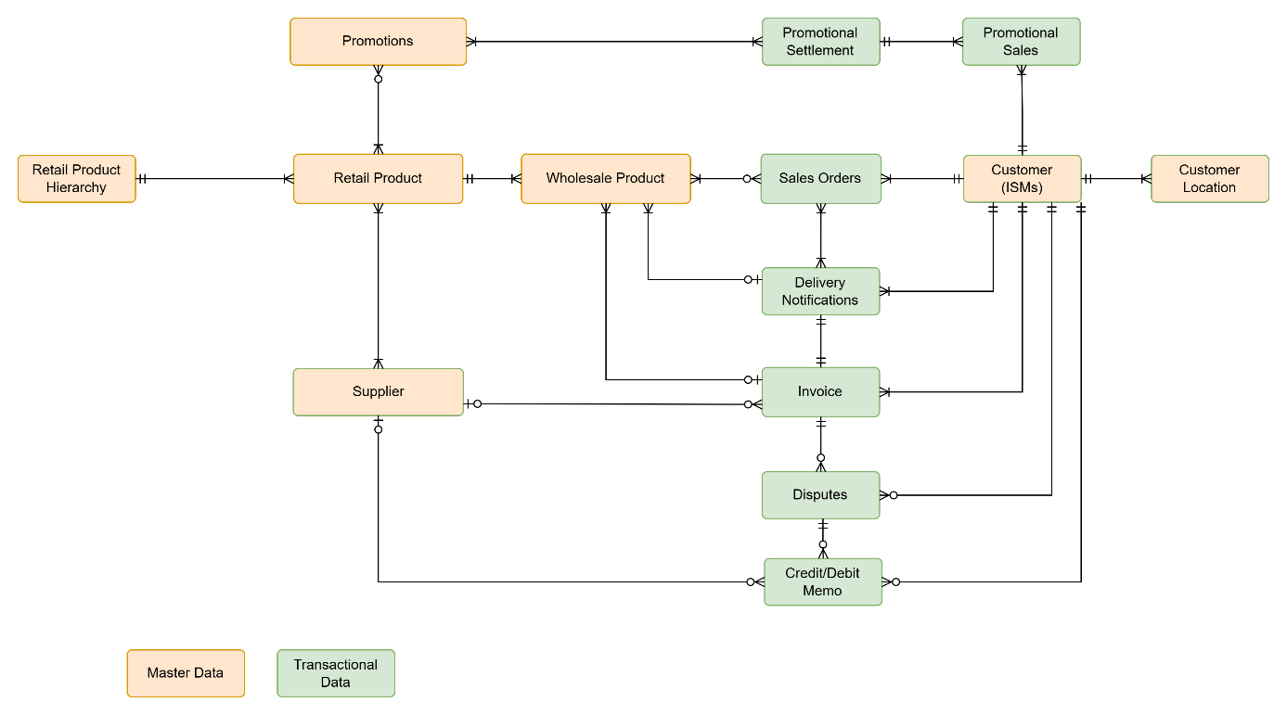

Conceptual Data Model

8. Functional Requirements

8.1 Master Data
API first approach will be streamlining the master data exchange between Co-op (TCG and the ISMs with secure file feeds (via SFTP) as a fallback for ISMs not yet API-ready.

Master data services component:
- Will process the master data messages in the order they are received from core retail systems and stores them in a persistent data store.
- Persistent data store will be designed to serve the master data requests received via APIs as well as daily/weekly master data feeds.
- Populate data store for various master data entities – Product, Price, Promotion, Product Hierarchy and Supplier and support requests for master data via APIs.
- Range information consisting of Planogram files and PSA files will be made available via File feeds only.
- Serve the real time API requests for master data and produces Daily delta file feeds and Weekly full master data feeds.

TCG is introducing two distinct Product data concepts:
Retail Products - Retail Product is a physical item, or a service offered to consumers in a retail store or via other retail channels e.g. e-commerce. It will contain key information like the Retail Product Code, Article.
Wholesale Products. -Wholesale Product contains multiple items of the same Retail Product, it can be ordered by an organisation and delivered to a Retail Store from a Distribution Centre.
This separation ensures ISMs receives the right information—consumer-facing details for retail items and logistics-focused information for wholesale supply.
The master data currently contained in CRTG.DAT file, where generated by TCG's chosen technologies, will be maintained in new SAP-sourced Master Data files, so that the data is in a suitable location.

8.1.1 Products
- The complete set of product data to be sent by week -4, so that all relevant data is present and accurate upon activation of the product.
- All product descriptions to be formatted in a consistent manner, so that it follows agreed business brand standards and can be used without the need for manual editing.
- Product size information to be broken down into separate fields, so that the data format matches the system and allows the ISM to be legally compliant. Example - Data broken down into separate fields of 'weight' and 'unit', e.g. '275' and 'grams' as opposed to '275 grams’.
- All product weight information and associated units of measure to be provided separately from the product description, so that there is consistency in the data and no potential for misinterpretation.
- A report to be sent in a timely manner informing responsible teams when the shelf-life information changes on products, so that they can be amended in the systems accordingly.
- A clear notification process needs to be in place for delta changes to order point hierarchies, including information relating to the dates of changes, so that responsible teams will have enough time to plan accordingly and make appropriate amendments based on these changes.
- All data in the Ranging Files need to match the Master Data file, so that there are consistency and the accuracy of this data is maintained.
- Master Data file needs to include flags pertaining which HFSS criteria a product belongs to, so that the product as per HFSS standards can clearly be labelled.
- A flag for any deltas on allergen values changing needs to be populated, so that responsible teams be aware of these changes in a timely manner and can update as appropriate.
- A daily update is required for compliance data in the Master Data file, so that responsible team can ensure the data is accurate in the system and meet legal requirements for declaring the origins for products in store.
- The ABV percentage for a product attribute needs to be as part of the Master Data file, so that we can ensure the products affected have the appropriate level of data.
- A Statement Report showing the legally stated ABV data is required, so that we have a legal reference point when submitting data.
- An 'Alcoholic' vs 'Non-alcoholic' flag to be included in the Master Data file, so that certain products can be easily differentiated when gathering and submitting ABV data.
- A weekly notification regarding the list of products that have ‘Restricted Orders’ at the respective depot is required, so that responsible team kept up to date on any changes and can take timely action.
- The minimum product data information to be provided by week -7, so that we have sufficient time for a range review and product set up.
- All orderable product master data to be locked down 48 hours before the ordering day, so that we can rely on the products being correct at the time of order.
- The orderable product data in the RADR (Reports used for Range and Space management) is validated against Supply Chain 'live to order' product shipping from depot.
- All live product master data to be completed and readily needs to be available as soon as it is updated, so that we have an up-to-date view on the lines available for order.
- Daily master data needs to be received as a delta report, so that any updates can be clearly seen.
- All relevant information needs to be included in both the ERC (Emergency Range Change) and the Master Data File when the former is published, so that there is consistency between the two.
- Dimension data needs to be accurate before it is published in the Master Data file, so that this information can be used in a reliable manner.
- All information on a GSMO2 form to be accurate, so the data is the final version to be used.
- Product descriptions in SAP needs to match those in the GSMO2 document, so that there is consistency between the two.
- All Unit of Measurement descriptions need to match those in the GSMO2 document, so that there is consistency across the board.
- A proactive notification from TCG with instructions needs to be sent out as soon as something new appears on a GSMO2, so that we will have a clear idea on what to do in response.
- The formatting of the GSMO2 to be consistent each time, so that it can be easily read and understand the changes being made.
- The GSMO2 to inform if a product has regional and depot restrictions, so that we have clarity on ordering the products.
- The GSMO2 needs to be ready at week -12 before go-live to enable responsible teams sufficient time to plan.
- Communication from TCG regarding the reason for a product being discontinued needs to be in place, so that we understand whether the product has been discontinued from range or from the business entirely.
- The range needs to be consistent between TCG and the suppliers, so that the data being held is accurate and up to date.
- The Tobacco Matrix to be maintained in the future ways of working, so that it continues to be used as the source of data relating to tobacco funding. And the columns to be standardised, so that the information is presented in a uniform, consistent manner each time.
- A flag at line level stating if a product in a 'deal' contains alcohol is required, so that it is easy to identify as there will be age-related restrictions.
- All buy in and sell out dates to be confirmed at Week -4, so that societies can do business activities such as allocations.
- EDLP-style products to be flagged in the 'One-Off' file, so that my society knows not to build allocations around them.
- Clear communication on which products are relevant to which plans, so that we have sufficient level of information.
- An indication for each product is required if it is a repeat, change, new or delist, and any associated past product identifiers, so that we can correctly plan based on previous season and reduce the time spent product matching.
- Notification if a product is a contingency line, so that we can plan and act if necessary.
- Wine taste notes to be included in the Master Data file, so that this information can be displayed to the customer.
- Societies to be informed if a supplier has recalled a product, so that it can be taken off sale and stock balances can be adjusted.
- Information to be included stating how to cook/heat bakery products, so that store colleagues are informed correctly.
- We want to receive a notification when the duty type changes for a product in the Master Data file, so that we can take appropriate action in a timely manner.
- Total Litreage by EAN data is required to be in product master record.
- Consistency in the application of terminology across all files is required, so that automated software can read and translate data points easily.
- Any ‘Should Have’ requirements which use existing data (e.g. RTM spreadsheet, SAP Articles report) to continue until those requirements are MET, so that existing processes are not impacted.
- A notification of any new products added to the Product Master Data file is required, so that society can activate that line.
- 'Effective Start and End Dates' to be included on all notifications received about changes to product hierarchies, so that the society can ensure the data held is accurate and coordinated with these changes.
- A notification is required about the products that are available to order in certain regions, so that the society can make informed decisions about ordering appropriately.
- A notification is required when the age restriction changes for a product, so that we can take appropriate action and in a timely manner.
- Specific attributes relating to allergen information to be included in the Master Data file, so that we can ensure the product data is up to date as appropriate.
- Able to receive the supplier’s name and ANA code as part of the Master data file, so that we can accurately identify certain products.
- Information is required relating to the Expected Product Life of a product in the Master Data file, so that we can prepare in advance in the event stock is limited.
- The forecast lead times for PAC changes to be shared in the form of a worst-case scenario, so that the expectations are set immediately on the timeframe for these changes.
- A final confirmation flag to be included for a new product, so that we can see when a product has been set up in the system.
- The clone product to be identifiable by EAN, so that we have a consistent method of identifying the product.
- Variant codes to have a start and end validity date for when it is live, so that we know at what point it is an orderable product.
- A notification to be sent at the start of each Business Day informing my society of any Product Attribute Changes, so that we kept up to date on a regular basis.
- 'Gross Weight' information is required , so that we have accurate weight information for retail units.

8.1.2 Prices
- The Manufacturer's Suggested Retail Price (MSRP) to be included on the GSMO2 when a product is added, so that the appropriate level of pricing information is in the master data record and available in master data file.
- Any pending cost price changes for new products being set up to be highlighted and date stamped, so that we are made aware of these changes.
- The Master Data file to have the most up to date cost prices and changes by Friday of each week, so that the information is available at the correct time.
- A single view of all cost prices and pending validity dates in the Master Data file is required, so that the source of the data is clear and easy to find.
- The published cost price to be included in the GSM02 price file when a new line is set up, so that we have the required level of information at the start of a product's life.
- The cost price to be published in the Master Data file for the lead times of specific range events, so that it accurately reflects the price depending on these different timings.
- The Minimum Alcohol Floor Price to be included in the cost price set up in the Master Data file, so that we have this legally required data sent by TCG in a consistent and accurate manner.
- The notification regarding draft cost price changes to be retained, so that it matches what has been outlined in the BSA.
- Retail price to be maintained in the Master Data file, so that we have up to date and accurate price data being fed through.
- The Master Data file to include a flag for the cost price of primal meat, so that appropriate retail/cost prices can be set on the sellable units.
- Both parts of the ERC pricing documents to be completed and sent at the same time, so that we can activate an ERC.
- Delta flags in the Master Data file are required for any changes to the Minimum Alcohol Floor Price, so that it is easy to spot if any changes have been made.
- Cost price changes to include a delta notification, so that we can clearly see what updates there are.
- The delta notification to contain all the cost price changes together, with a separate flag for any cost prices relating to promotional activity, so that we have clear visibility of all the changes in one place.
- Every cost price change record in the Master Data file needs to have a date stamp, so that we have visibility on when the changes took place.
- Any price changes for PMP/catchweight products to have validity dates associated with them, so that we know on what date the changes are taking place.
- AlcoholMSRP to be shared in the Master Data file, so that I have the sufficient level of price information available in this file.

8.1.3 Promotions
- All data fields in the existing FRTS Promo File to be maintained, so that we continue to have the data we need.
- The start and end dates for promos to be included in the Master Data file, so that we are receiving the data we need to understand the timeframes for a promo.
- The SELs and overall marketing messages for promos to be shared as separate entities, so that we have clarity on the separate messages that are to be presented for the promotions.
- The buy in and sell out dates to be maintained in the promo file, so that we have this up-to-date information being fed through.
- All promotional information to be locked at Week -4, so that societies have time to make decisions on stock builds.
- A full Funding Output report to be sent on Day -1 relating to promo amendments, so that we have a full report before go-live to be able to refer to.
- Any promo retail prices to have start and end dates, so that there are clear instructions as to what these timeframes are.
- The promotions dataset to be locked down at Week -4, with an indicative report also being available from Week -7, so that the societies have an appropriate amount of time to make business decisions.
- New lines associated with promotions to be managed by the 'standard new line process', so that there is consistency in the way these activities take place.
- Seasonal Range Document to be fully completed 4 weeks before the planogram promo cycle commences, so that we have enough time to plan.
- A delta report is required to state whether a PMP is new, changing or stopping, so that we have clear visibility on these changes.
- Any promo amendments to be flagged daily as a delta report, showing document changes, so that we have daily visibility of these changes.
- We need to ensure that all types of changes relating to promo amendments have appropriate delta flags associated with them, so that we are informed on the specific changes taking place.
- The Promo Calendar format needs to include start and end dates, with the ability to also export these dates, so that the information is easy to follow and make use of.
- A delta notification for changes in the Promo Master File is required, so that we are kept up to date and able to take timely action if needed.
- All relevant information relating to one-off allocations to be included in the Promotional Information field, so that my society knows why it is being promoted and able to make decisions based on this information.
- Any late promo or exit activity to be treated as a new activity, along with an explanation as to why they are taking place, so that a consistent and transparent procedure occurs.
- The PAM Pack to continue to be published and available Week -7, or earlier if the Approval Meeting has taken place, so that all relevant data is available to us in time to plan for the Promotion.

8.1.4 Suppliers
There may be more than one active Supplier of the Retail Product at any given time.
Key information for supplier master data record to include the following.
- Supplier Name
- Supplier Code
- Supplier ANA Code (Location of a Supplier contact)
- Address Details

8.1.5 Product Hierarchy
The hierarchy will begin at the lowest level with each entry pointing to the next level up, and so on until you reach the top level of the Hierarchy i.e. Level 1.
There will be 6 levels of hierarchy for individual retail products’ classification (6 being the lowest)

- Data relating to chilled orders need to be broken down into the full chambers, so that they can be identified exactly which category they fall into.
- All product hierarchy layers to be included in the Master Data file when it is sent through, so that all the information the society needs for product grouping is presented together.

8.2 Transactional Data

8.2.1 Sales Order
- A notification a week in advance is required regarding any change to Order Day information in the Master Data for depot orders, so that sufficient time is enabled to make changes.
- A clear notification of the products present on 'Seasonal Switch-Off lists' for depot orders is required, so that we can plan around these events and ensure we can deal with changes in ordering.
- The 'Switch-off List' for Christmas orders at depot to be sent no later than the 1st of November, so that I have sufficient time to adapt and fulfil orders despite vendor shutdowns.
- A 'Pre-engagement' notification from TCG is required before any changes occur relating to seasonal ordering, so that we have plenty of time to plan and act.
- All products offered by direct to store suppliers to be supplied by TCG, so that I have the information needed to prepare for a range event.
- Access to previously live product rejection reports is required, so that we can complete this step before placing an order.
- Cloning information to be available 4 weeks before go-live, so that we have sufficient time to plan.
- TCG giving a clear indication as to when discontinued products will 'run out' in depots, so that my society is confident that when orders are placed on the new line, they are available.
- The validity dates for FSDUs to be shared, so that we know at what point they are orderable.
- All products to have a flag on the Master Data file showing the Order Placement Time, so that we know at what point these products must be ordered by.
- We need to know if there are any order limits to a product, so that the correct orders can be placed across that and other products.
- We need to ensure the key information contained within CRTG.DAT, EDN, Promotions, Current Order, PSA, any other Open Access Reports (e.g. RADAR) where generated by TCG's chosen technologies, is to be maintained in SAP-sourced Master Data files, so that the data is accessible is the new solution format.
- When ordering direct to store delivered products from a vendor, we want the vendor master data to be made available, so that so that we have an appropriate level of ordering information for business insight purposes.
- Ability to validate that a product has a live, orderable status, so that we can place an order for it.
- A robust support mechanism needs to be available from TCG, so that we can manually escalate any issues with Supply Chain Partnerships.
- Master data to be shared at frequent, regimented times of the working day, so that we have regular updates which we can prepare for.
- Complete a new store setup form providing all required data and attributes at an agreed lead-time date, so that the set-up is completed within the agreed timeframe.
- Manual notifications for Direct to Store vs Depot orders to be clearly broken down in a suitable manner, so that it is clear what the product and the orderable number is.
- Flags for products with Restricted Orders to be included in the Master Data file for depot orders, so that we have up to date information regarding the days they can/cannot be ordered and delivered.
- Vendor information to be included in the Master Data file, so that we have the appropriate level of vendor information held.
- A flag in the Master Data file is required to identify any days that orders cannot be delivered to store, so that we can take appropriate ranging action and with sufficient advanced notice.
- All relevant direct to store vendor codes need to be present in the Master Data file, so that we have all information needed to place an order.
- Any minimum order quantity values to be present in the Master Data file, so that we understand limitations that are present when placing orders.
- We want to know what the last order date is for a product flagged as discontinued, so that we know up to which day we can continue placing orders.
- ANA Code to remain as the primary identifier for any store, so that we can easily identify stores as per the current way of working.
- TCG to maintain accurate available to order dates and notify of changes either way, so that we can avoid manually checking the orders.
- All available master data to match TCG's data and be presented in real-time, so that we are able to obtain a live and consistent snapshot of the data.
- The master data currently contained in CRTG.DAT file, where generated by TCG's chosen technologies, will be maintained in new SAP-sourced Master Data files, so that the data is located in a suitable location.

8.2.2 Order Acknowledgements
- In the event of a line order not being fulfilled, a report detailing the reasons for this and what actions to take, so that I am able to proceed with orders moving forward without disruption.
- All amended direct to store schedules to be managed by TCG and sent in the Master Data, so that the data is being sent in an organised and consistent manner for societies to act.
- A delta flag showing changes in direct to store scheduling to be included in the Master Data file, so that we can prepare delivery changes well in advance.
- Notifications relating to 'emergency changes to orders' to be sent in a timely manner, so that society has enough time to be able to act.
- We need to be informed in the event a supplier does not fulfil the current order into depot, so that reordering stock can be completed quickly and efficiently.
- A notification from depot is required informing us what has been held back (in the event of an emergency left-off delivery), so that we are provided with sufficient detail.

8.2.3 Electronic Delivery Notifications (EDNs)
- A notification for any cages on the EDN but left off the vehicle is required, with a forecast also included for when they expect to be delivered, so that we are kept up to date and able to keep track.
- Master Document to be maintained with all information relating to missing or late cages, so that we have a full picture showing these occurrences.
- Have visibility on the line level detail for a cage being held, so that the stores know not to inventory reset.
- An error report to be maintained highlighting if an EDN report is stuck somewhere in the system, so that we can be notified, and act if needed to correct the process.
- Communication relating to left-off cages to be shared multiple times a day, so that my society is given a consistent level of visibility.
- To have full visibility of a live copy of a logistics delivery store risk assessment, so that we have the required level of information needed.
- Deliveries to be automatically booked into the system when the cage is scanned in on the Handheld Terminal (HHT) upon confirmation of receipt, so that we can streamline the delivery process and minimize manual errors.

8.2.4 Invoices
Invoice data feeds will include both Depot Invoices (for goods delivered from a depot) and Direct Invoices (for goods delivered directly from Suppliers).
- Each invoice needs to have one-to-one relationship with an Electronic Delivery Notification (EDN) and references the Sales Order associated with that EDN.
- A process needs to be in place to be able to follow if information changes relating to Accounts Payable, so that we have visibility of this and know exactly what actions the ISM needs to take.
- SAP Finance files to remain in the current structure following NSL retirement, so that the data is in a recognised format.
- SAP Finance files to be amended with key data which is currently used (e.g. GTIN), so that the data is in a recognised format.
Key information for invoices to include the following:
- Co-op Company Details (Address, Contact Details, Registration Number, VAT Registration Number, Alcohol Wholesale Registration Number)
- Depot Details (for depot orders)
- Customer Details (Address, Contact Details)
- Customer Store Details (Address, ANA Code, Location Reference)
- Supplier Details (for direct orders)
- Invoice Reference and Date, TCG Order Reference
- Product Details
- Quantity Invoiced
- Total Wholesale Cost per Line Item
- Unit Cost
- VAT Code, VAT Percentage, VAT Amount per Line Item
- Total Invoice Charges (including warehouse charges, VAT on warehouse charges, etc.)

8.2.5 Claims

8.2.5.1 Credit/Debit Notes
A billing document will be issued to correct/adjust the amount invoiced, in case of discrepancy, returned goods etc.
- Credit/Debit Notes should reference the original invoice and associated Delivery and Order details to ensure accurate reconciliation. They can apply to both Depot Orders and Direct Orders, depending on the source of the goods.
Key information for Credit/Debit Notes to include the following:
- Co-op Company Details (Address, Contact Details, VAT Registration Number)
- Customer Details (Address, Contact Details)
- Customer Store Details (Address, ANA Code, Location Reference)
- Depot Details (for depot orders)
- Supplier Details (Supplier ANA Code, Credit Memo Reference for direct order claims)
- Claim Type (e.g., Credit Memo) and Claim Reason
- Invoice Details, Delivery Reference, and Order Reference
- Product Details (Catalogue Item Code, EAN, Quantity Invoiced, Wholesale Price, Unit Price, VAT Details)
- Total Claim Charges (including warehouse charges, VAT on warehouse charges, etc.)

8.2.6 Promotional Sales Volumes
- Data to be used to evidence the sales performance during the Promotional period and to support claims for Promotional funding from Suppliers.
- Promotional sales capture details of the Promotion or offer, the Products sold under that Promotion, and the associated sales quantities and dates to ensure transparency and accuracy in Supplier claims.

Key information to include:
- Customer Reference
- Promotion/Offer Reference
- Product Code/EAN
- Sales Date & Qty

8.2.6.1 Promotional Settlement
TCG to share Promotional settlement (the summary of promotional funding earned under agreed contract conditions) with ISMs.
It needs to provide the settlement amounts and credits based on actual Promotional sales.
Key Information include:
- Co-op Company Details (Address, Contact Details, VAT Registration Number)
- Customer Details (Address, Contact Details)
- Claim Type (e.g., Credit Memo) and Claim Reason
- Settlement Document Details, payment terms, Condition Contract reference, settlement period details, Vendor fund details, Promotion Reference
- Product Details
- Value of settlement, including and excluding VAT, Promotion redemption value, and VAT Details
- Total settlement value, including and excluding VAT

8.3 JDA (Blue Yonder) – Range and Space (Including Planograms and RADR Reports)
- Blueprint documentation for range and space to be refreshed every quarter, so that the data is being updated in a consistent manner.
- Bay break for each store cluster category in the blueprints to be sent via TCG, so that we can accurately plan the layout of the store.
- Range Calendars to be locked 16 weeks in advance of the 2- or 3-star events going live, so that we have sufficient time to plan in preparation.
- 1-star events to be correctly defined, so that any ambiguity is avoided and it is clear what the required parameters are.
- Strategic view of range calendars to be locked in within 6 months of them going live, so that we have the appropriate amount of time to plan and act.
- Clear reporting against the scale of change to any 3-, 2-and 1-star events is required, so that we are kept up to date and able to adapt depending on the changes.
- Any strategic reasoning or change associated with 3-star events to be published well in advance, so that we have sufficient advanced notice to be able to prepare and act.
- A notice regarding any structural changes to categories is required well in advance, so that we have sufficient time to be able to prepare and act. (12 weeks in advance?)
- 1-star events to be locked in an appropriate timeframe (12 weeks in advance), so that we have time to plan ready for the go-live date.
- Visibility on seasonal range calendars one year in advance of the event is required, so that we have sufficient time to plan.
- Event calendars to be published 8 weeks before they come into force, so that we have sufficient time to plan.
- ERCs to be published 7 days before the date of delivery for orders, so that we have sufficient time to act.
- The live orderable date to be accurate, so that we have confidence that planogram updates are reflecting the correct information.
- A notification is required that an ERC is taking place, so that we are made aware that this is happening and able to plan accordingly.
- ERC family of files to be date stamped, so that the latest files are being used for clarity.
- GSMO2 to be confirmed as the final, locked version at the point of publication of planograms, so that we have confidence the product data set will remain the same.
- Information relating to distribution changes to be maintained within the RADR, so that we have enough information to be able to plan and act.
- Planogram changes to match promo feeds, so that the data is consistent between the two.
- Planograms for promo space to be ready by Week -7, so that we have sufficient time to plan and act before go-live.
- The RADR to be fully up to date when planograms are published, so that the data is accurate and consistent across the files.
- We need to be informed when and why a change has taken place in a planogram, so that we understand the context and are able to make appropriate decisions as a result.
- Allocation Confirmation sheet to be published within a week of the date the form has been sent, so that we have evidence the allocations have been completed.
- Allocation Rejection report to be published, so that we have evidence of any allocations that have not been sent through.
- Clear timeframes need to be in place for One-Off allocations, with Week-7 for the template, Week -6 for the return of this template, and Week -4 for confirmation, so that we have sufficient time to act and respond as necessary to fulfil the requests.
- A contingency process to be designed for late allocation processes, so that there is a standard procedure to follow.
- All regional variants of promo planograms to be updated as rigorously as other planograms, so that it is kept up to date and accurate.
- PDF versions of planograms to be locked at Week -3 with up-to-date data, so that we can use these with confidence that they are accurate at the point of use.
- Information relating to the seasonal DEGs (Deletion Exception Groups) needs to be received at the beginning of November, so that we can prepare in advance how to manage the store space.
- Regional information to be included in ERC notifications, so that we understand whether the products in question are impacted from a legislative perspective.
- PSA for 2- and 3-star events to be published no later than 7 weeks before the event goes live, so that we have sufficient time to plan and act.
- PSA and all supporting documentation, including deltas, to be showing the correct and up to date Product ID, so that the information being used is accurate and reliable.
- All points of dimension data to be accurate on plans by the time they are published at Week -7, so that we have the correct data in preparation for planning.
- Any notification of orderable product code linked to range to be date stamped, so that there is a clear indication which one will be live at the point of order and delivery.
- Unused products to be purged from planograms, so that only live products are present.
- Only 'actual' products need to be present on planograms, so that these are all orderable.
- 4 weeks’ notice for any changes to merchandising type needs to be received, so that we have sufficient time to plan and act.
- Global RADR report to be included in the Master Data, so that I can see all the products offered by TCG.
- All appropriate columns on the GSMO2 form to be filled in correctly, so that all the required data is present.
- All information on a GSMO2 form to be replicated from the master data, so that the data being fed into our systems is matching and consistent.
- Information by TCG needs to be provided regarding a clear differentiation between 3- and 2-star events, so that we know the difference between the two and to avoid any ambiguity.
- Strategic positions on changes to range calendars needs to be given in the form of clear communication, so that we are updated by the most relevant people and able to take appropriate action.
- The format of Range Planning Calendars needs to be system readable, so that we can easily take the information without issue.
- Clear and visible confirmation is required when updates to calendars have taken place, so that we are kept up to date with these changes.
- Email notification is required when a PSA has been published, so that we are kept up to date.
- We need to be provided with a clear understanding of the strategic direction of planograms in advance of them being published, so that we are kept in the loop and able to plan appropriately.
- All timeframes need to be kept at 7 weeks if TCG delay planograms, so that we still have the required amount of time to prepare for go-live.
- ERCs to be accompanied with a clear rationale from TCG, so that we understand why the change is taking place and any subsequent action to take.
- We need to ensure that an ERC displays a clear link between a product coming into the range and the product being removed, so that we understand how the changes link 'new and old' together.
- Both PAC and ERC processes need to use live EANs, so that the related products associated with the product identifiers are correct and up to date.
- A flag showing the supply route for an FSDU required with an indicator as to whether it is reusable, and a flag showing any regional constraints, so that we have all necessary information on hand to make informed decisions.
- ERCs provided by TCG to be highlighted via a daily delta file that will include all changes on the plans accompanied by a Validity Date, so that it ensures plans are kept up to date and minimises downstream issues.
- JDA to be the master for orderable product data, so that it ensures the data is accurate and reliable.
- We need to know the date that a plan goes live in store, so that we can plan appropriately prior to this happening.

9. Support

9.1 Schedules
- Schedule in the Trading Plan to be maintained, so that it can drive activity for resource planning.
- Trade Plan to capture the dates for when allocations will be sent out and need to be returned by, so that my society has time to allocate resources.
- Dates on the Seasonal Calendar to have a tier indicator, so that we can identify the scale and importance of the event when looking at the calendar.
- Delta notifications to be included on the Seasonal Calendar for anything that can change, so that we are made aware and able to act if needed.
- Back-up copies of all comms/notifications regarding deltas to be sent to centralised locations, so that all societies can reference them if needed.
- Any communication regarding planning events to be published on the FRTS website as a minimum, so that we have a consistent location to check for these.
- TCG to provide societies with appropriate planning and tools, and in a timely manner, if they expect societies to complete certain activities, so that our society has the right amount of time and resource to complete these as expected.
- Schedules for 'Show & Tells' to be shared on the Trade Plan, so that we are kept informed and able to act if needed.
- Visibility on the start and end dates of marketing campaigns are required, so that we can plan resource in stores accordingly.
- A delta notification for any changes is required after the original template for seasonal cycles is published, so that we can see these changes and act in a timely manner if required.
- In-store delivery date for empty FSDUs to be shared, as well as the route to market, so that we have the appropriate level of information on hand to make decisions.
- A delivery schedule for all temperature regimes, with indicative times for store scheduling is required, so that we can make decisions regarding order volumes for when stock will sell.
- A 6-week minimum notification period for schedules to be sent, so that it allows sufficient time for store planning.
- A minimum of 7 days’ notice for any emergency ad-hoc changes to the schedule on a store-by-store basis is required, so that we have sufficient time to plan and act if needed.
- All relevant scheduling information relating to a new store opening is required, so that we can plan appropriately and keep track of the steps.
- One agreed source is required for how delivery schedules are published, so that the information we are receiving is consistent.
- Direct deliveries to be managed in the same formal manner as depot deliveries, if the expectation is for TCG to be fully involved, so that we are confident the process will be followed in an organised and informative manner.
- A process needs to be in place to allow an emergency schedule to be created within 24 hours, so that disruptions are minimised in the event of an emergency.
- A report is required informing us which products missed their expected allocation windows, so that we are kept up to date of any unexpected changes.
- Visibility of direct to store vendor order placement and delivery data to coordinated schedules, so that stock transactions can be completed efficiently.
- All Head Office details to be aligned to a single identity, so that the IDs being used are consistent and accurate.
- A process needs to be in place allowing us to keep track of any progress for changes relating to Delivery Schedules, so that we can plan and act if necessary.
- A checklist needs to be created of every single allocation package associated with an event, the dates of publication for the first view, and the expected submission date, so that we can keep on top of planning and preparation for the event.
- The Proforma document to include appropriate product identifiers, so that it is easy to identify lines within the document.
- Delta notifications are required for any changes within the Trade Plan and associated products, so that we are made aware of these changes and able to act if needed.
- The 'Planning Tool' to give an indication of the type of allocation data return that is needed at that allocation period, so that we understand the context of the specific plan.
- The 'key, 'star' and 'featured' lines in Allocation Templates to be flagged and indicated, so that we can differentiate these from other lines.
- Visibility required on any seasonal event with a national marketing campaign, so that we are kept informed and able to act if needed.
- Any exception schedules to have start dates, with the ability to also overlay existing schedules, so that we understand when these schedules will be in action.
- A document showing 'Average Delivery Times' for stores is required to be sent once a month, so that we can keep track of these over a period.
- Twilight Indicators for deliveries are required, so that we know at what time of the day they are scheduled.
- Any Composite Deliveries to be flagged, so that we can see which lorries are transporting all types of deliveries in one go.
- Re-notifications to be sent each time a cage continues to be left off, until it is eventually delivered, so that we are kept up to date and able to keep track.
- Information relating to store closures to be held on the Master Data file, so that we have the appropriate level of information available.
- Exceptions to normal delivery schedules relating to public holidays to be shared by TCG, so that we have the appropriate level of information available.
- A database to be held for all ad-hoc annual events, with the ability to indicate if a store is impacted by these, so that we have appropriate visibility in the event my society needs to act.
- All schedule planning documents to indicate if a store is impacted by public dates, so that we have appropriate visibility in the event my society needs to act.
- An indicator flag in scheduling documents is required showing us which depot a frozen load is being sent from, so that we have sufficient visibility.
- An indicator is required in appropriate documents showing us whether a store can accept composite deliveries, so that we are able to plan a delivery strategy in the event they are being sent.
- The Master Data file to highlight delivery days that cannot be used, so that systems are populated correctly without manual intervention.
- Detailed notification is required at a line-level on the cages that get "left off" the lorry, so that we know exactly which products are missing from the delivery.

9.2 Documentation & Communication
- A Data Dictionary needs to be created, so that we have a reliable source we can use to understand terminologies and data points.
- A documentation needs to be created and maintained that establishes how data flow to and from an ISM works, so that we have a clear source to refer to which helps us map out the processes.
- Master Data to be updated in line with any 'amend comms' being issued to ISMs, so that the information available is consistent and up to date.

10. API Capabilities & Behaviour
API Platform will implement APIs in line with the TCG API guidelines and security controls.

10.1 Delta Queries
Delta query parameter will allow ISMs to retrieve only the master data records that have changed since the last successful synchronisation and can query to up to previous 7 days.

10.2 Authentication & Authorisation
The API platform will implement OAuth 2.0 Client Credentials flow leveraging to provide secure, standardised authentication for API communications between ISMs and TCG

10.3 Pagination
The API Platform will implement pagination framework to efficiently handle large datasets of master data.
Default pages size will be setup based on the typical payload sizes, will be configurable.

10.4 Rate Limiting
Rate limiting will be implemented by the API Management platform to protect APIs from overuse and ensure fair access. API Clients will receive rate limit information in responses to help manage usage. Early warnings and graduated responses (like delays or blocks) will be implemented to maintain system stability and minimise disruption.

10.5 Request Validation & Data Handling
API Platform will implement request validation and data validation to protect against incorrect payloads, large payload sizes.
The Requests from Partners will be validated for:
- Query string/header validations
- JSON Schema validation
- Payload size validation

10.6 API Versioning
API Platform will implement versioning approach in line with TCG API standards to ensure backward compatibility (n-1, n being the latest version) while supporting ongoing platform improvements.

10.7 API Contracts
API Platform will implement versioning approach in line with TCG API standards to ensure backward compatibility (n-1, n being the latest version) while supporting ongoing platform improvements.

10.8 Error Handling
A structured error handling solution will be implemented, which provides clear feedback to clients.
The API Platform will provide standard HTTP status codes with detailed JSON messages to aid troubleshooting without exposing sensitive data.
Errors will be categorised as client or server issues, with full request context logged for analysis. Correlation IDs will be included to enable end-to-end tracing.

11. Business Clocks
Business clocks for various processes outline all required activities, highlight the critical path, and identify key milestones. These clocks, defined for different business processes, directly impact ISMs— particularly in terms of receiving master data and submitting orders to TCG. Processes affecting master data include Range events (3*, 2*, 1*), seasonal events, Emergency Range Changes (ERC), and Product Attribute Changes (PAC). In addition to Range-related events, Promotions and Price changes also contribute to updates in the master data provided to ISMs.
As part of the proposed solution for NSL Retirement, there are no changes proposed to the business clocks around Range, Seasonal, Promotional, ERC and PAC changes. ISMs will be aligned to TCG Business clock for all Range, seasonal and Promotional events.
The business process supporting these events will be reviewed against any off-system activity including the forms used to exchange information. This includes seasonal business process, and the forms used to exchange seasonal forecasts will be amended to include the newly proposed catalogue item codes.

11.1 Business Clocks – AS-IS

11.1.1 Range Events
The Range Event process is used to update categories on shelf Range, whether reacting to market conditions, financial performance or driving corporate strategy, by removing / introducing new Products.
The following table describes various Range events and other processes that will result in changes to master data shared with ISMs and associated key milestones.
- GSMO2 – Pre event notification, shared via Email/FRTS Website to ISMs.
- Planogram Publication – Available via Open Access portal to download to ISMs.
- Master Data Publication – Primarily via CTS feeds, but use of emails/SharePoint.
Event | What is involved | GSM02  Publication  Milestone | Planogram&  RADR Reports  Publication  Milestone | Master Data Publication  Product,  Price,  Vendor  Milestone
3* Event | Full strategic review, all Products, subcategories, clusters, and kit in scope  for potential change. Involves Assortment optimisation and Markdowns. | Week -18 | Week -7 | Week -23
Seasonal | Less scope than 3* but includes assortment optimisation and markdowns. | Week -16 | Week - 7 | Week -22
2* Event | Less scope than 3* but includes assortment optimisation and markdowns. | Week -14 | Week -7 | Week -20
1* Event | Minor non-strategic actions, such as variety, weight or Supplier enforce change. No Assortment optimisation or markdowns. | Week -7 | Week -6 | Week -8
ERC | Ad hoc, includes  removal and/or replacement of  Products, to cater for  - Unavoidable supply issue affecting Production (e.g. factory fire, salmonella outbreak)  - Exceptional Waste  Legislation Change | No GSM02 | Day -4 | Day -12
PAC | Non-Article number change, i.e. within an ‘Article’ change, includes UOM changes and Barcode changes | No GSM02 | No changes to  Planograms | Day -1, 1700  – Manual notification  Day -1, 23:30 CTS feeds

11.1.2 Promotional
The following table describes various events and other processes that involves sharing Promotional information with ISMs and associated milestones.

Milestone | Activity
Week - 12 | ISMs receive pre-event notification of Promotions, via Promotional pack (approved Promotions for the period)
Week – 9 | FSDU and one-off Ordering begins
Week – 8 | ISMs send Promotional volumes to TCG.
Week – 7 | ISMs access signed off Planograms& RADR Reports.  Draft Promotional feed sent to ISMs (CSV & Excels on FRTS website)
Week – 2 | ISMs receive final Promotional data feed (CSV & Excels on FRTS website)
Week – 1 | ISMs submit orders for Ranged articles (Before 04PM)
Week 0 | Promotions & planograms goes live in stores
Week 2 onwards | ISMs start sending Promotional sales volume to TCG (weekly), Starts 10 days after Promotion goes live in stores
Week 3 | Promotional period ends

11.1.3 Price Changes
The following table describes various events and other processes that involves sharing Price change information with ISMs and associated milestones.

Milestone | Activity
Day -28 | TCG issues draft Price change notification to ISMs
Day -23 to Day -21 | Whole Prices start flowing to ISMs via master data feeds
Day -21 | ISMs receive final notification of new Price proposal
Day 0 | Price is live stores

11.1.4 Ordering Business Clock
The following diagram explains various activities, milestones involved in the Sales Order process between ISMs and TCG.
- Ambient & frozen orders submitted outside ordering will be processed next day.
- Fresh orders submitted outside ordering window will be rejected.
- Any issues with master data in Order file submitted by ISMs, the corresponding lines will be rejected at the time order validation by Middleware.
- Issues with master data at order processing in SAP, will result in the whole order being rejected and requires manual intervention.
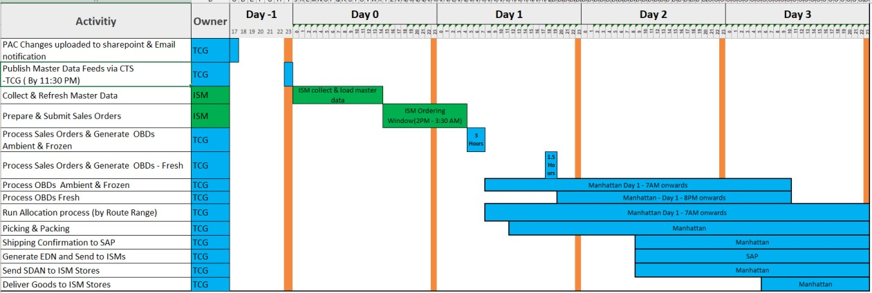

ISM Ordering Business Clock

11.1 Business Clocks – TO-BE
The frequency and timing of master data publication from TCG will be updated as part of the proposed design. Master data changes will be exported from SAP multiple times a day and made available to ISMs via proposed APIs/File feeds. This ensures that ISMs receive the most up-to-date master data (reflecting changes made on Day -1 of the ordering window), enabling them to submit Sales Orders with accurate and current information.
The specific frequency of these SAP master data exports will be agreed during the detailed design phase and validated through performance testing. This is necessary due to the resource intensity of master data export processes.
The ordering window is currently defined as between 14:00 – 03:30 hours.
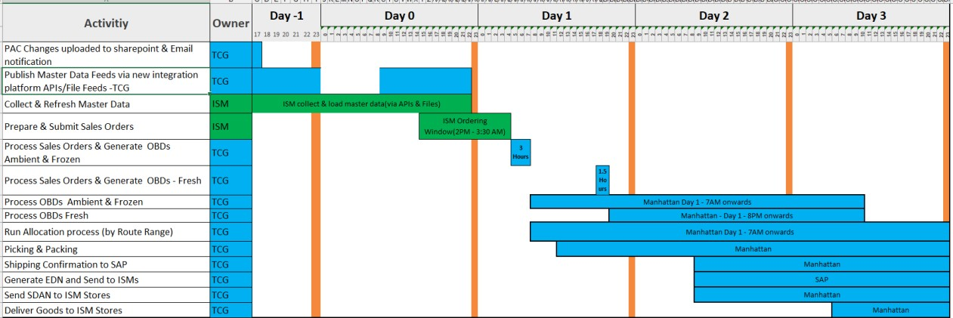

To
-
Be Order processing Window

12. New Product Identifier Structure – TO-BE
The NSL Product Identifier will be replaced with a Catalogue Item, which uniquely identifies a Wholesale Product and associated Sales Order unit. The Catalogue Item will be supported with all the corresponding data that is required by ISMs to order products from TCG. The Catalogue Item will be an alpha numeric code.
A ’Standard Product Code’ will be included as part of the master data and can be used to group related items together for the purposes of reporting by ISMs.
When referencing or querying a product as part of enquiries, the Catalogue Item code will be used to identify the Wholesale Product and will be the common identifier between TCG and the ISMs.
The Catalogue Item code structure is illustrated in the following diagram.

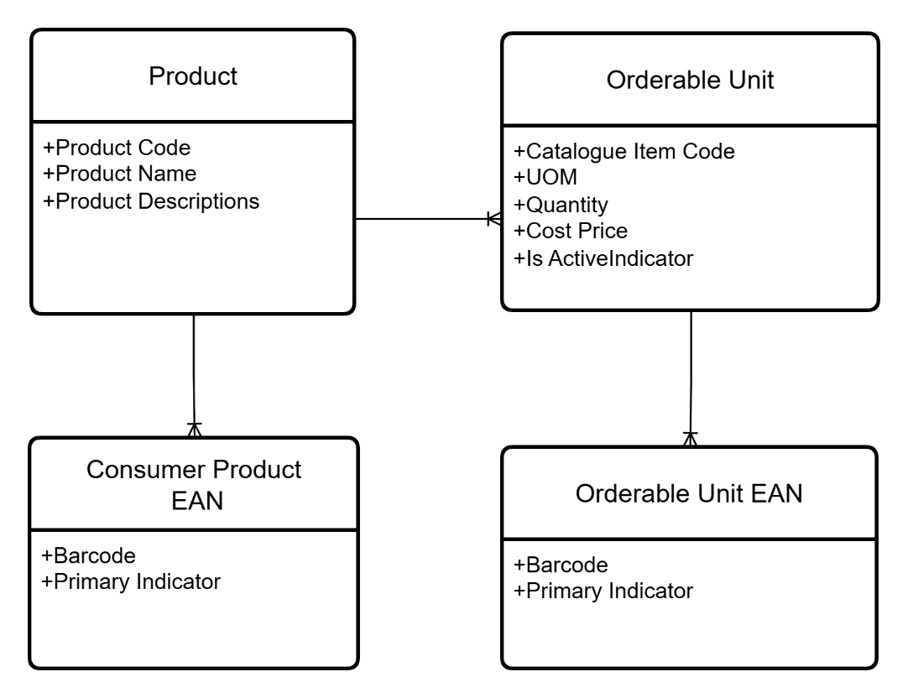

Catalogue Item Structure

13. Integration Requirements
To modernise data exchange with ISMs and other partners, TCG will implement an Integration platform that delivers core master and transactional data services, primarily via APIs with file feeds (SFTP) as an alternate secondary channel. Master data including Product, Price, Promotions, Product Hierarchy, Range and Supplier information will be sourced from core retail systems SAP and JDA (also referred as Blue Yonder). Transactional data will follow the same pattern, with APIs introduced for submitting Sales Orders and retrieving the Order Acknowledgements and EDNs. This integration approach aligns with Co-op’s ‘API First’ strategy and delivers FRTS/ISMs requirements.

The diagram below illustrates the new integration architecture that will support the new solution.

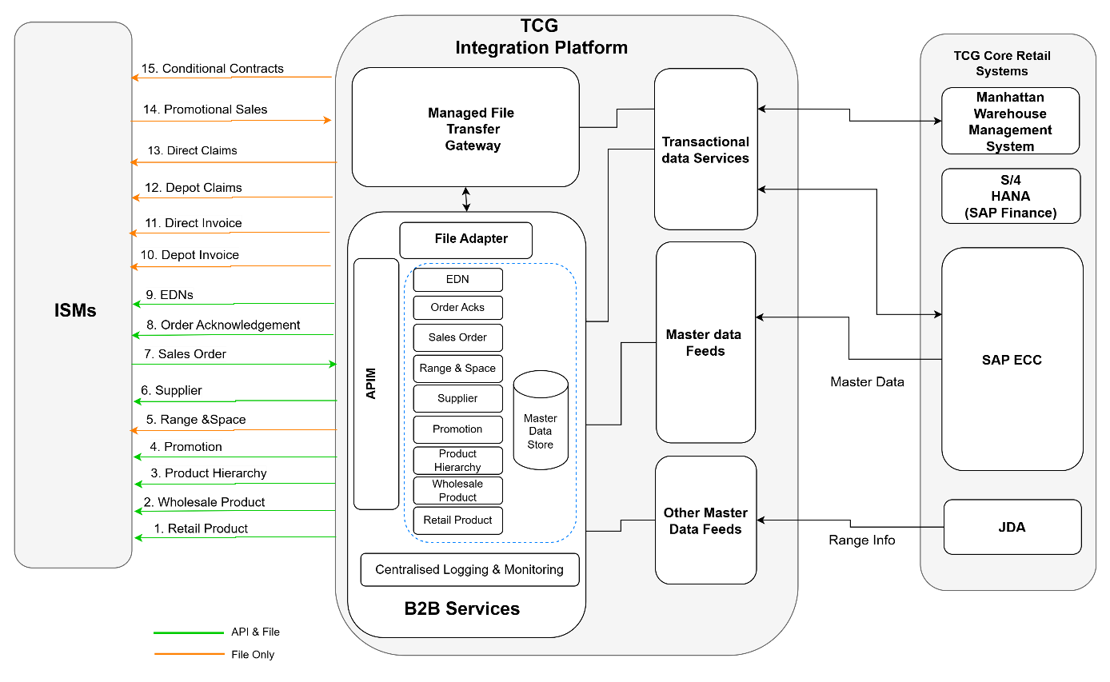

To
-
Be Integration Flows

LINCOLNSHIRE INTEGRATION REQUIREMENTS – VIKAS

Please Refer to Appendix1 for details.

14. Risks & Mitigations
Ref | Risk | Mitigation
R001 | Not all the ISMs will be able to consume the APIs, due to their level of integration maturity, resulting in delays to NSL Retirement. | Continue to support ISMs who are not yet ready to consume APIs through sharing file-based master data using the new feeds.
R002 | High volume master data changes such as Product, Prices and Transactional APIs like Sales Orders can overload the APIM and back-end systems resulting in slow response times, timeouts, and outages. | Provide master data via APIs only for delta changes for a pre-defined window (e.g. Today (-  7 Days)  Implement pagination and filtering for APIs  Restrict full master data refreshes to file feed.  Implement rate limiting and quotas per ISM/wholesale customer to control load for all the APIs.
R003 | Master data provided via API vs file feeds may be inconsistent, if produced from a different internal data components or application logic. | Ensure APIs and File feeds are generated from  same source, application logic and follow the  same JSON Schema  Use common transformation logic and integration flows to prevent discrepancies
R004 | FRTS readiness – the TCG implementation approach may be far quicker than that available to ISMs resulting in a long transition period. | Supply initial design fundamentals to ISMs to enable early engagement with their 3rd party partners
R005 | ISM Resource availability – There is a risk that some of the ISM’s key technical and business teams needed to support the NSL retirement project are concurrently working on other internal & Buying Group projects impacting design review/approvals and impacting the project timelines. | TCG Project Manager to engage with each ISMs to ascertain realistic timelines for design
R006 | SAP Finance line level invoicing and credit note flat file outputs are currently structured with Article + UOM, NSL and GTIN. Some ISMs are using the NSL for the purposes of Branch Charging and Invoice Reconciliation against legacy data sources. The scale and complexity of remapping finance systems to new data sources may add additional development time for ISMs | TCG has previously committed to retain the current flat file format for line level invoicing from ECC for the medium term. This should be considered to cover the full transition of all Societies off NSL based master data. The invoice format, in containing space for three methods of product identification, offers an option to replace the Article number with the new Catalogue Item Code allowing the invoice format to be maintained while allowing ISMs to transition from the legacy product identifier to the new one

LIST OF LINCOLNSHIRE RISKS

15. Assumptions

Ref | Assumption Description | Mitigation
AS001 | All the ISMs will each receive the same master data set (Products, Prices, Promotions, Range, Supplier). | None. As per business process/business rules.
AS002 | ISMs are all at varying levels of integration maturity, some are already following API First approach, and some are not. | File feeds will be implemented for the ISMs, who cannot onboard to API based master data exchange.
AS003 | TCG core retail systems (i.e. SAP and Blue Yonder  (JDA)) will be the systems of record for master data. | Not Applicable
AS004 | The principle of ordering directly from suppliers will continue to reside with ISMs. | Impacts will be reviewed during Low-level Design
AS005 | The Deposit Return Scheme project will be making changes to master data in SAP due to regulatory requirements. | Align with the DRS project team, on the data structure dependency and update NSL design proposals thereafter.

LIST OF LINCOLNSHIRE ASSUMPTIONS

16. Dependencies

Ref | Assumption Dependency
D001 | There is dependency that ISMs update their internal systems to process the new API and file formats.
D002 | There is dependency that ISMs adopt the newly proposed orderable Product Identifier in place of legacy identifier (i.e. NSL) for Sales Order submissions within the transition period agreed.
D003 | The transition period for migrating all ISMs from NSL to newly proposed orderable Product Identifier along with the newly proposed APIs/File formats must be agreed.

LIST OF LINCOLNSHIRE DEPENDENCIES

17. Success Criteria

- Regular data updates from TCG within agreed timelines and intervals
- Data consistency
- No data discrepancies between systems (TCG and Lincolnshire Co-op)
- Platform displays correctly on all devices
- No Pricing discrepancies
- No Stock discrepancies

18. Implementation Approach

WE NEED INFORMATION FROM TCG

19. Timelines

Key Stage | Target Date

20. Glossary of Terms

TERM | DEFINITION
FRTS | Federal Retail Trading Services – Central buying and logistics group for the UK’s Co-operative societies.
ISM | Independent Society Member – Legally independent regional  co-operative businesses that are part of a larger co-operative family
TCG | The Co-operative Group – Parent Entity, national Co-operative family
NSL | National Stock Listing – Product Identifier used for ordering
ERP | Enterprise Resource Planning - A category of Business Management Software
POS | Point of Sale – Exact time and place where a retail transaction is completed.
WMS | Warehouse Management Systems – Software Solution which manages inventory and supply chain fulfilment operations.
PIM | Product Information Management – Centralised software used to store, enrich, and manage all the data for products
EDN | Electronic Delivery Notification – Automated digital update to inform the customers about their order status. Provides details of shipped goods.
HFSS | High Fat, Sugar, and Salt – Food and drink products that are classified ‘less healthy.’
API | Application Programming Interface – Type of software interface Connection between computers or computer programmes used for real-time data exchange.
BSA | Buying Services Agreement – A legally buying contract between a client and a buying agent or service provider.
ERC | Emergency Range Changes – Rapid adaptation of product assortments, supply chains, and facility protocols to navigate disruptions, crises or shifting safety mandates.
CTS | Corporate Trading System – Software architectures used to execute, manage, and analyse transactions. Co-op’s legacy master data system.
UAT | User Acceptance Testing – Final phase of software testing where real end users test the software in real-life scenarios.
KDD | Key Design Decisions – A strategic, high-level artifact used to document significant business, process, or system decisions made during a project lifecycle.
JDA | Known as Blue Yonder – Software used to manage supply chain and retail planning.
RADR | Reports used for Range and Space management shared with Independent Society Members.
PSA | A file type used for a retail space-planning layout.
JSON | Text- based data interchange format used for exchanging all the master data with the Independent Society Members.
MSRP | Manufacturer's Suggested Retail Price – The price a manufacturer advice retailer to charge for a product.
SFTP | Secure File Transfer Protocol – A network protocol used to securely access, transfer and manage files.
ABV | Alcohol By Volume – A global measurement that indicates the exact percentage of pure alcohol present in each volume of an alcoholic beverage.
GSM02 | File format used for pre-system notifications such as range changes and product updates.
EDLP | Every Day Low Pricing – A retail pricing strategy where a business maintains consistently low prices across its entire inventory.
SUPPLIER ANA CODE | A code which identifies the exact location of a Supplier contact. The code conforms to ANA (Association of National Advertisers) standards and is either the Supplier's EDI (Electronic Data Interchange) code or is generated on TCG Corporate Locations Database.
EAN | European Article Number - Also known as GTIN (Global Trade Item Number), used for product identification via 13-digit barcode.
PLANOGRAM | Visual representation of product placement on shelves, used for Space planning.
DEG | Deletion Exception Groups – Specific constraint errors (open orders, pending inventory etc) that temporarily block the system from successfully purging these items.
FSDU | Free – Standing Display Unit (or Floor- Standing Display Unit) –  A Storage Fixture placed directly on the shopfloor to showcase products.
OAUTH.2.0 | Authentication protocol used to secure API access with token-based credentials.
HTTP | Hyper Text Transfer Protocol – The foundational set of rules that allows web users and websites to communicate with each other over the internet.
PAC | Product Attribute Changes – Updating specific details of an item such as its size, colour, material, or price etc..

Appendix 1
S. No | Data flow | Status | Direction | Source  System  (of Data) | Target  System  (of Data) | Data Content | Integration  Method | Frequency
1 | Retail Product | New | Outbound | TCG Core  Retail  System | ISMs | Provides the information related to Retail Product, Product Identifiers, Product Characteristics, Retail Price, Cost Price, and other related information that are relevant to ISMs.  The API Supports:  Retrieving latest information of Retail Products that were introduced/changed since last refreshed by ISMs for up to previous 7 days.  Refresh a single Retail Product by providing the Product Code, irrespective of when it was last changed.  Used to synchronise the Retail Products  This could look like:  GET /Products?changedSince=2025-11-20T00:00:00Z GET /Products/{ProductCode}  Key Information includes:  Product Characteristics  Product Grouping Category  Consumer Product EAN  Product Packaging Specification  Retail Bill of Material  Selling Restrictions  Tax Categories  Retail Price  Cost Price  Delta file feeds Includes all the changes that were made to the retail Product information with in TCG’s Core retail systems, since the last extraction of master data shared with ISMs via file feeds.  Weekly full load files include all the Retail Product data relevant to ISMs, irrespective when they were updated.  The Retail Product information (i.e. data attributes) provided in APIs and file feeds will be the same. | API + SFTP | APIs – Periodic polling  Files:  Daily Delta  Feeds  Weekly Full feeds
2 | Whole  sale Product | New | Outbound | TCG Core  Retail  System | ISMs | Wholesale Product data flow provides the information regarding Wholesale Products that can be ordered by an ISM from TCG and associated information. This includes the latest Catalogue Item code to be used while placing the orders with TCG.  The API Supports:  Retrieving latest information of Wholesale Products introduced/changed since last refreshed by ISMs for up to previous 7 days.  Refresh a single Wholesale Product by providing the Catalogue Item code, irrespective of when it was last changed.  Used to synchronise the Wholesale Products  This could look like: GET / wholesaleProducts?changedSince=2025-1120T00:00:00Z  GET / wholesaleProducts /{CatalogueItemCode}  Key information includes:  Catalogue Item code, Sales Order Unit  Retail Product Code, Description  Wholesale Product EANs  Wholesale Price  Delta file feeds Includes all the changes that were made to the wholesale Product information with in TCG’s Core retail systems, since the last extraction of master data shared with ISMs via file feeds.  Weekly full load files include all the Wholesale Product data relevant to ISMs, irrespective when they were updated.  The Wholesale Product information (i.e. data attributes) provided in APIs and file feeds will be the same. | API+SFTP | APIs – Periodic polling  Files:  Daily Delta  Feeds  Weekly Full feed
3 | Product Hierarchy | New | Outbound | TCG Core  Retail  System | ISMs | Provides information on structure of the Product Hierarchy including parent-child relationships between different levels.  The API Supports:  Retrieving latest information of Hierarchy nodes that were introduced/changed since last refreshed by  ISMs for up to previous 7 days  Used to synchronise the Product Hierarchy information  This could look like: GET / hierarchies?changedSince=2025-11-  20T00:00:00Z  Delta file feeds Includes all the changes that were made to the Hierarchy information with in TCG’s Core retail systems, since the last extraction of master data shared with ISMs via file feeds.  Weekly full load files include all the Hierarchy data relevant to ISMs, irrespective when it was updated.  The Hierarchy information (i.e. data attributes) provided in APIs and file feeds will be the same. | API + SFTP | APIs – Periodic polling  Files:  Daily Delta  Feeds  Weekly Full
4 | Promotion | New | Outbound | TCG Core  Retail  System | ISMs | Integration that provides Supplier Funded Promotional information.  The API Supports:  Retrieving latest information of active/upcoming Promotions that were introduced/changed since last refreshed by ISMs for up to previous 7 days.  Refresh a single promotion by providing the Promotion ID, irrespective of when it was last changed.  Used to synchronise the promotions  This could look like: GET /Promotions?changedSince=2025-11-  20T00:00:00Z  GET /Promotions/{id}  Key information including:  Promotional Period, Start Date, End Date  Promotion Type (Link-Save, Multi-Save, Price Promotion)  Promotional Prices  Retail Products associated with Promotion  Supplier Fund information  Delta file feeds Includes all the changes that were made to the promotion with in TCG’s Core retail systems, since the last extraction of master data shared with ISMs via file feeds.  Weekly full load files include all the promotion data relevant to ISMs, irrespective when it was updated.  The promotion information (i.e. data attributes) provided in APIs and file feeds will be the same. | API +SFTP | APIs – Periodic polling  Files:  Daily Delta  Feeds  Weekly Full feed
5 | Range &  Micro Space | New | Outbound | TCG Core  Retail  System | ISMs | This integration facilitates the distribution of planograms and PSA Files.  Planogram files include the information of:  Implementation Date  Order Date  Category Information  Product Code, EAN, Product Name, Size, Facings, Capacity  RADR files, will continue to be made available via Open Access portal only. | SFTP | Tbc – During detailed design
6 | Supplier | New | Outbound | TCG Core  Retail  System | ISMs | Supplier information for all the Products made available to ISMs.  The API Supports:  Retrieving suppliers whose data added/changed since last refreshed by ISMs for up to previous 7 days.  Refresh a single supplier data by providing the Supplier code, irrespective of when it was last changed.  Used to synchronise the supplier data.  This could look like: GET /suppliers?changedSince=2025-11-20T00:00:00Z GET / suppliers/{id}  Includes details of:  Supplier Name  Supplier Code  Supplier ANA code  Address Details  Delta file feeds Includes all the changes that were made to the  Supplier information with in TCG’s core retail systems since the last extraction of master data shared with ISMs via file feeds.  Weekly full load files include all the Supplier data relevant to ISMs, irrespective when it was updated.  The supplier information (i.e. data attributes) provided in APIs and file feeds will be the same. | API + SFTP | APIs – Periodic  polling  Files:  Daily Delta  Feeds  Weekly Full feed
7 | Sales Order | Changed | Inbound | ISMs | TCG Core  Retail  System | Integration of wholesale customer Sales Order from  FRTS/ISMs into SAP.ISMs can submit Sales Orders via API or file feeds using Managed File Transfer Gateway.  The API Supports:  Submitting a single new Sales Order to TCG  Real time validation of order information submitted.  Idempotency check to prevent duplicate Sales Orders  Used to submit Sales Orders for Wholesale Products  The API supports only submission of new Sales Orders in initial release. In future iterations of this API, it may be expanded to support submitting bulk orders, order cancellations, and order amendments.  This could look like:  POST /orders  Includes the following information:  Customer Identifier  Customer Order Reference  Customer Store Reference  Customer Store location Reference  Catalogue Item (i.e. the Wholesale Product)  Requested quantity.  Note: The file-based Order submissions will support multiple orders in the same file. | API + SFTP | APIs – Ad hoc  Files - Ad hoc
8 | Sales Order  Order Acknowledge ment | Changed | Outbound | TCG Core  Retail  System | ISMs | Order Acknowledgements from TCG to FRTS/ISMs.  ISMs can retrieve Order Acknowledgement via Polling the API or from Managed File Transfer Gateway.  The API allows ISM to retrieve Order Acknowledgement for a single order.  This could look like: GET /orders/{CustomerOrderReference}  Order Acknowledgement information include:  Customer order number  Status of the order  Received line-item count  Error Line-item count  In future iterations of this API, it may be expanded to support retrieving acknowledgements in bulk.  Delta file feeds include all Order Acknowledgements available since the last set was shared with ISMs via file feeds.  The Order acknowledgement information (i.e. data attributes) provided in APIs and file feeds will be the same. | API + SFTP | APIs – Periodic  polling  Files – Daily
9 | Electronic  Delivery  Notification  (EDN) | Changed | Outbound | TCG Core  Retail  System | ISMs | Integration of Outbound Delivery Data from TCG Systems to wholesale customer to share EDNS.  The API allows ISM to retrieve Electronic Delivery Notifications filtered by a specified date and time.  This could look like: GET /deliveryNotifications?ChangedSince=2025-1120T00:00:00Z  Key Attributes include:  Customer Identifier  Customer Order Reference  Customer Store Reference  Delivery Reference  Items delivered – Catalogue Item code, Product code  Shelf-life information  Quantity, Weight information  Distribution Centre information from which the goods dispatched  Delivery Date  Delta file feeds include all EDNs available since the last set was shared with ISMs via file feeds.  The EDN information (i.e. data attributes) provided in APIs and file feeds will be the same. | API +SFTP | APIs – Periodic  polling  Files – Daily
10 | Depot Invoice | Changed | Outbound | TCG Core  Retail  System | ISMs | Invoice information for the goods delivered from TCG Depots.  Includes information of:  Coop Company Details, Address, Contact details,  Registration Number, VAT Reg Number, Alcohol Wholesale Registration Number  Depot details from where goods delivered  Customer Details, Address, contact details  Customer Store Details, Address, ANA Code, Location Reference  Invoice Reference, Date  TCG Order Reference  Product Details, Product Code, Catalogue Item Code, EAN, UOM,  Quantity invoiced  Total wholesale cost per line item  Unit Cost  Currency  VAT Code, VAT Percentage, VAT Amount per line item  Total invoice charges, warehouse charges, VAT on Warehouse charges etc. | SFTP | Daily
11 | Direct Invoice | Changed | Outbound | TCG Core  Retail | ISMs | Invoice information for the goods delivered from Suppliers directly to ISM stores.  Includes information of:  Coop Company Details, Address, Contact details, Registration Number, VAT Reg Number, Alcohol  Wholesale Registration Number  Supplier Details, Supplier ANA Code  Customer Details, Address, contact details  Customer Store Details, Address, ANA Code, Location Reference  Details, Address, contact details  Invoice Reference, Date  Supplier Invoice Reference  Product Details, Product code, Catalogue Item Code, EAN, UOM,  Quantity invoiced  Total wholesale cost per line item  Unit Cost  Currency  VAT Code, VAT Percentage, VAT Amount per line item  Total invoice charges, including and excluding VAT | SFTP | Daily
12 | Depot Claims | Changed | Outbound | ISMs | TCG Core  retail  System | Claims settlement information for disputes related to Depot orders.  Includes information of:  Coop Company Details, Address, Contact details, VAT Registration Number  Customer Store Details, Address, ANA Code, Location Reference Customer Details, Address, contact details  Depot details from where goods delivered  Claim Type (e.g. Credit Memo), Claim Reason  TCG Invoice Details and Delivery Reference, Order Reference  Product Details, Catalogue Item Code, EAN, Quantity invoiced, Wholesale Price, Unit Price, VAT Details  Total Claim charges, warehouse charges, VAT on Warehouse charges etc. | SFTP | Daily
13 | Direct Claims | Changed | Outbound | ISMs | TCG Core  retail  System | Claims settlement information for disputes related to Direct orders.  Includes information of:  Coop Company Details, Address, Contact details, VAT Registration Number, Alcohol Registration Number  Supplier Details, Supplier ANA code  Customer Store Details, Address, ANA Code, Location Reference  Customer Details, Address, Contact details  Dispute Reference  Credit Memo Reference  Invoice Reference, Payment Terms  TCG Invoice Details and Delivery Reference, Order Reference  Product Details, Catalogue Item Code, EAN, Quantity invoiced, Wholesale Price, Unit Price, VAT Details  Total claim value, warehouse charges, VAT on Warehouse charges etc. | SFTP | DAILY?
14 | Promotional Sales | Unchanged | Outbound | ISMs | TCG Core  retail  System | Promotional sales submitted by ISMs to evidence the sales for supporting the supplier invoices and claiming the share of Promotional fund.  Key information include:  Customer Reference  Promotion/Offer Id  Sales Date  Sales Quantity  Product Code/EAN | SFTP | Weekly
15 | Condition Contracts | Changed | Outbound | TCG Core  retail  System | ISMs | Weekly file providing the condition contract settlement information to ISMs.  Key information include:  Co-op company details (Address, Contact Details, VAT Registration Number)  Customer Details (Address, Contact Details)  Claim Type (e.g. Credit Memo) and Claim Reason  Settlement Document Details, Payment Terms, Condition Contract Reference, Settlement Period Details, Vendor Fund Details, Promotion Reference  Product Details (Catalogue Item Code, EAN, Quantity)  Value of settlement, including and excluding VAT, Promotion redemption value, and VAT details  Total settlement value, including and excluding VAT | SFTP | Daily

